**COAL SEAM GAS PRODUCED WATER TREATMENT**

DESIGN CREDIT(CHN1010)

Professor - Vikky Anand

Student Name - Karan Pratap Singh Rathore

**Coal Seam Gas**

Coal seam gas is a natural gas held in coal seams under pressure by groundwater. Coal seam gas wells release the gas by reducing the stress through groundwater extraction.

**Produced Water**

Extracted water and gas are diverted to surface infrastructure treatment and processing plants. The extracted water is termed ‘coproduced water’ (also referred to as ‘produced water’ or ‘associated water’)

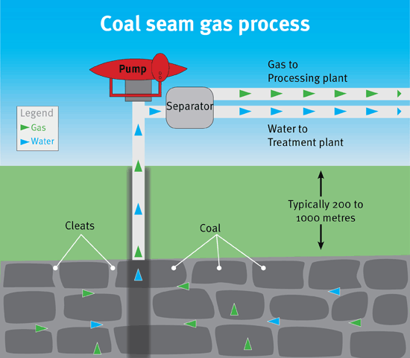

**Volume of Co-produced Water**

The volume of co-produced water can vary significantly between individual wells, coal seams and coal basins depending on geological conditions. During the planning phase for gas field development, estimates of co-produced water volumes are necessary to formulate appropriate management arrangements. As the gas field is further developed, more representative data is available on well yield, enabling volumetric predictions to be refined over time. The total volume of co-produced water generated in Australia in 2013 was estimated to be approximately 18 500 megalitres

**Chemistry of Co-produced Water**

Co-produced water is generally brackish, with salinity levels ranging from about 300 to 10 000 milligrams per litre (mg/L). By comparison, the salinity of water supplies for Australian towns can range from less than 250 up to about 1000 mg/L [3], and seawater is about 35 000 mg/L [4]. Knowledge of the chemical makeup of co-produced water is important for its management. This knowledge is used to select appropriate treatment technologies to achieve an acceptable quality for the proposed end use(including discharge).

**METHOD OF TREATMENT OF CSG PRODUCED WATER**

|  |  |
| --- | --- |
| TREATMENT METHOD | DESCRIPTION |

**Primary Treatment**

|  |  |
| --- | --- |
| 1. Sepration   1)Gravity Sepration  2)Centrifugation | 1)Mechanism for settling heavier particles.  2)Uses centrifugal force for solid-liquid sepration. |
| 1. Filtration 2. Sand Filtration 3. Multimedia Filtration | 1)Remove suspended solids using sand as a medium.  2)Utilize multiple layers for enhanced particle removal. |

**Secondary Treatment**

|  |  |
| --- | --- |
| 1. Biological Treatment 2. Aerobic Processes 3. Anaerobic Processes 4. Chemical Treatment 5. Coagulation and Flocculation 6. Chemical Percipitation | 1)Oxygen-dependent microbial degradation of organics.  2)Microbial degradation  1)Aggregation of particles for easier removal.  2) chemical addition to induce precipitation |

**Tertiary Treatment**

|  |  |
| --- | --- |
| 1. Advanced Filtration   1)Membrane Filtration | Uses semi-permeable (RO, UF) for sepration. |
| 1. Adsorption   1)Activated Carbon  2)Adsorbant Polymers | 1)Aborbs organic Containments.  2)Polymers designed to selectively absorb containments. |

**Treatment System Components**

|  |  |
| --- | --- |
| 1. Pre-Treatment  * Screens and Grit Chambers * Chemical Dosing Systems | * Remove large particles and grit before main treatment. * Adds chemicals for pH adjustment and cogulation. |
| 1. Main-Treatment Units  * Clarifiers and settlers * Biological Reactors * Chemical Dosing Systems | * Settling tanks for sepration of soilds and liquids * Encourage microbial activity for organic removal. * Addition of chemicals for coagulation and flocculation. |
| 1. Post-Treatment  * Disinfection systems * pH adjustment | * UV or chemical methods for micro-organism removal. * Addition of chemicals for pH correction. |

The table overleaf comments on the components that are typically analysed for and compares the results obtained at several CSG recovery sites.

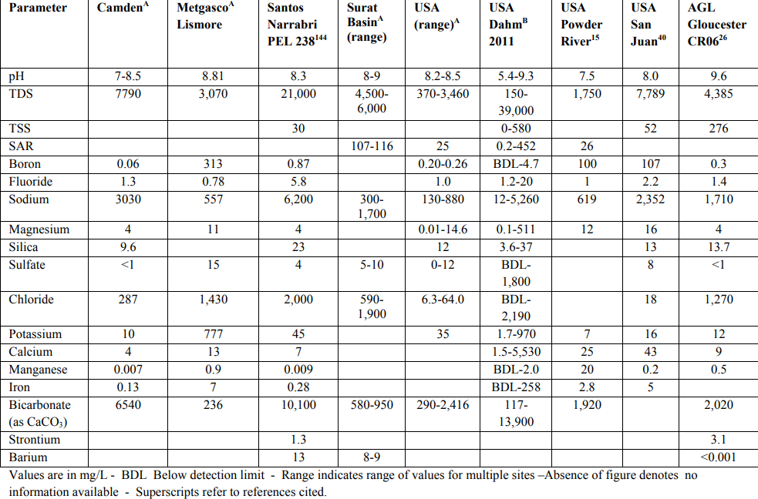

Coal Seam Gas produced Water Disposal Practices

* Reinjection

In many oil and gas operations, production water is treated and reinjected into the reserviour to enhance oil recovery and minimize environmental impact.

* Surface Discharge

Treated production water may be discharged into surface water bodies, subject to regulatory compliance and environmental standards.

* Evaporation Ponds

Evaporation ponds are used in some regions for the disposal of production water. The water evaporates over time, leaving behind concentrated salts and other contaminants.

* Reuse and Recycle

Some facilities implement water treatment technologies to purify production water for reuse in various industrial processes, reducing freshwater demand.

Factors Affecting Management Options:

* Regulatory Framework:

Compliance with environmental regulations and standards influences the choice of disposal methods.

* Geological Considerations:

The region's geology affects the feasibility of reinjection and deep healthy injection practices.

* Water Quality:

The composition of the water used in production determines the appropriate treatment and disposal methods.

* Local Ecosystem Impact:

The potential impact on local ecosystems and communities is critical in choosing disposal practices.

**Future directions: Knowledge gaps and strengthening the science**

The coal seam gas industry continues exploring options for managing and disposing of co-produced water and brine. These initiatives are, in part, a response to regulatory decisions that encourage companies to seek innovative solutions. There is ongoing research on treatment technologies that may be alternatives to, or used in conjunction with, reverse osmosis, such as ion-exchange treatment for sodium removal. Recent research has focused on characterizing the makeup of co-produced water in significant coal seam gas-producing regions. There are regional and temporal variations in co-produced water chemistry, and there are limited data on the potential occurrence of trace levels of organic compounds. Co-produced water management may require consideration at a catchment scale in regions with multiple coal seam gas developments. For example, critical load thresholds for water quality constituents include salt, nutrients, heavy metals, organic compounds, and suspended solids. The lack of available data on these constituents in discharge waters and the volumes of water that may be discharged has limited the scope of cumulative impact assessments. Improved data availability on co-produced water volumes and chemistry will enable consideration of cumulative impacts at a broader scale.

Characteristics of water before and after the pilot UF/RO treatment of CSG-produced water.

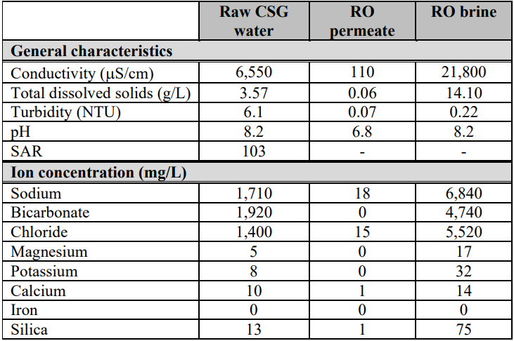

All of the work done in the report and Excel sheet data have been taken from the reference of 5 Science Direct Research Papers given by Sir and from the Government sites of countries.

* <http://www.australianminesatlas.gov.au/education/fact_sheets/coal_seam_gas.html>
* <http://en.wikipedia.org/wiki/Coal_bed_methane_extraction>
* <http://vimeo.com/53629052>
* http://www.energyaustralia.com.au/servlet/search?query=Santos+Gunnedah+Basi n+CSG+overview
* http://www.agl.com.au/~/media/AGL/About%20AGL/Documents/How%20We% 20Source%20Energy/CSG%20Community%20News/Gloucester/Factsheets/2013 /Exploration%20and%20Production%20CSG%20Fact%20Sheet%202.pdf